Topic 7: Theory of Evolution

Mechanism for Evolution
Charles Darwin concluded that biological evolution occurs as a result of natural selection, which is the theory that in any given generation, some individuals are more likely to survive and reproduce than others. In order for natural selection to occur in a population, several conditions must be met:
- Individuals in the population must produce more offspring than can survive. Human beings are somewhat unique among living things in that we can make conscious choices about how many offspring we have. Most other organisms, however, produce as many offspring as they can.
- Those individuals must have different characteristics. During Darwin’s time, no one knew where these differences came from. Now scientists know that differences in organisms arise due to mutations in DNA combined with the mixing of genetic information during sexual reproduction.
- Offspring must inherit some characteristics from their parents. During Darwin’s time, the laws of inheritance were just beginning to be figured out, so Darwin didn’t know exactly how parents passed on their traits. Modern scientists know that traits are inherited when parents pass genes on to their offspring.
- Organisms with the best-suited characteristics for their environment are more likely to survive and reproduce. This is the heart of natural selection. If there’s competition for survival and not all the organisms are the same, then the ones with the advantageous traits are more likely to survive. If these traits can be inherited, then the next generation will show more of these advantageous traits.
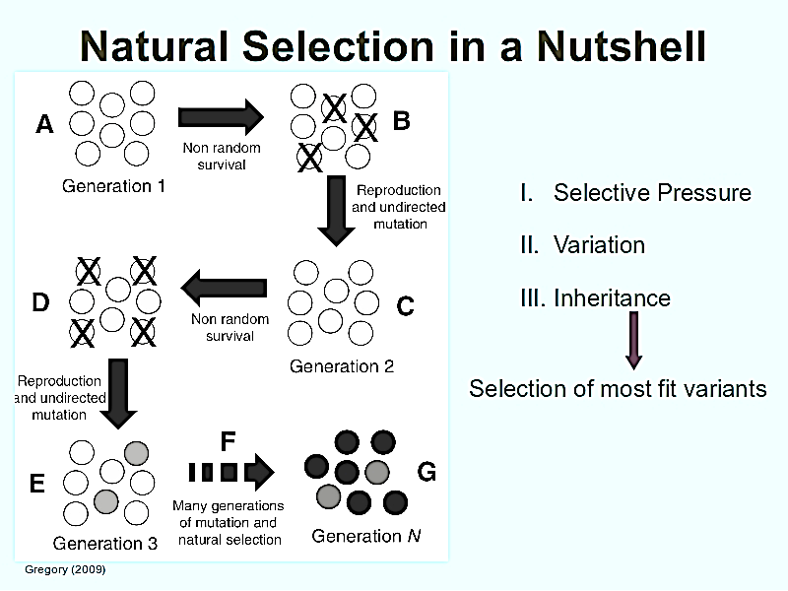
If these four conditions are met, then the new generation of individuals will be different from the original generation in the frequency and distribution of traits, which is pretty much the definition of biological evolution.
In addition, two other factors affect the genetic variability of a species
- Genetic drift: Either through a bottleneck (population crashes and greatly reduces number and diversity of population) or the founder effect (small group leaves to start anew…reduces number and diversity of population); the “new” population does not have the same frequencies or amounts of traits that were previously in the larger population
- Gene flow: organisms of the same species are able to move back and forth between areas to increase the variation of the population through sexual reproduction.

Evidence for Evolution
Previously, the main evidence for evolution was based on anatomy (structures) or physiology (functions) of organisms. Currently, comparing biochemical evidence (DNA, RNA, or protein sequences) provides scientists with the most detailed information. In general, the more similarities two organisms share, the more recently they diverged from a common ancestor.
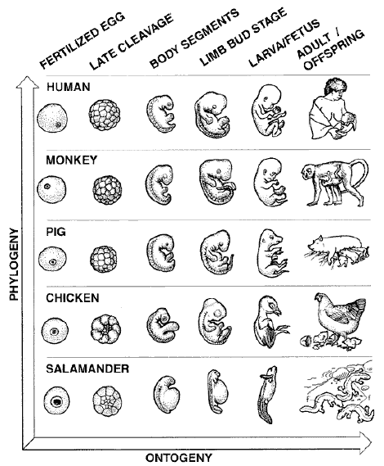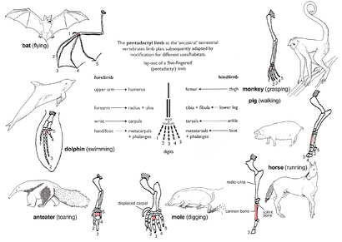
HOMOLOGOUS STRUCTURES are structures that have the same shape/form, but are used differently. The bones in the center are from the common ancestor, but each species has evolved to use them differently
EMBROLOGY compares the embryos of different species. The similar development patterns of the species above indicates that they shared a common ancestor

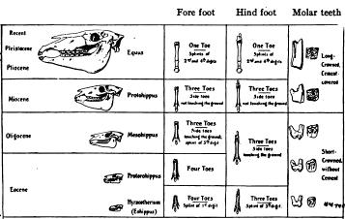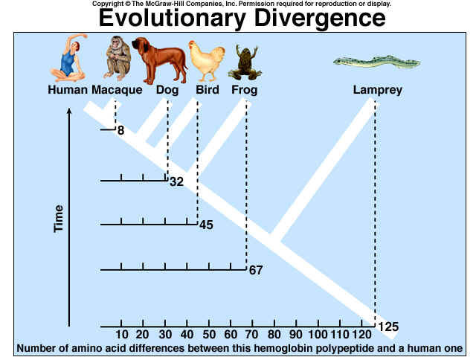
BIOCHEMICAL EVIDENCE compares the differences in either DNA or proteins (in this case, proteins. The lamprey has the most differences from humans, which indicates we diverged from the lampreys (are less related) much longer ago than the macaques (more related)
FOSSIL EVIDENCE links present day organisms to the common ancestors. Here we see the bones of modern horses (top) and how much it has changed from common ancestors (bottom)

Not shown are vestigial structures, which are structures, reduced in size that are no longer needed but were present in a common ancestor (think of the human tail bone or wisdom teeth. In addition, whales have tiny little hip bones but no legs, which suggest that that the ancestor of the whale walked on land and returned to the sea!). Also not shown are analogous structures, which are structures that look the same but are made out of different materials. This shows that species have changed to adapt to the environment in a similar manner.

