Topic 5: Cell Growth and Reproduction

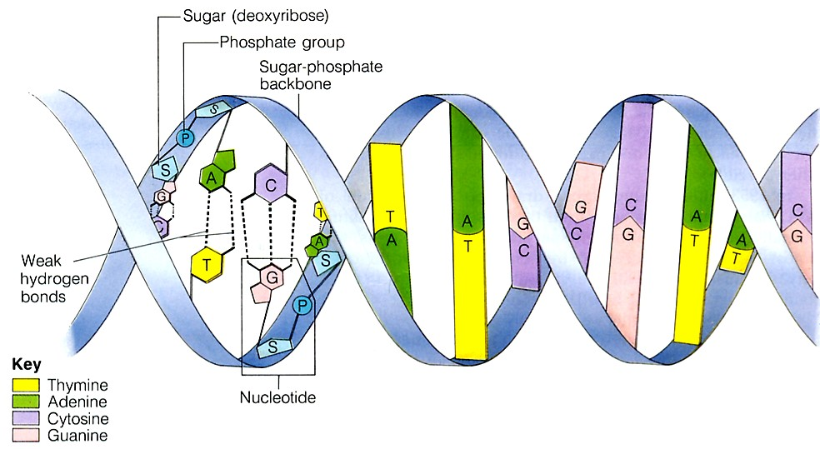
DNA Structure
Deoxyribonucleic acid (DNA) is an important biomolecule that contains our genetic code. Here is a diagram of the double helix model of DNA. Note that the monomers/building blocks of DNA are called nucleotides. Each nucleotide contains three parts
- Sugar (deoxyribose)
- Phosphate group
- Nitrogenous base (4 kinds)

DNA Replication
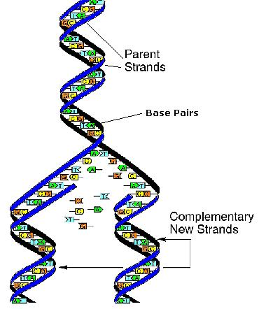
In order for new cells to pass on the genetic code, DNA must be copied inside of cells. In eukaryotic cells, this takes place inside of the nucleus, which stores the cell’s DNA. In prokaryotes, the process of copying DNA occurs in the cytoplasm. Regardless of location, the process is known as replication. Two daughter strands are formed.
- The double helix is opened up by breaking the weak hydrogen bonds
- An enzyme (DNA polymerase) comes in and adds new bases to the open strand
  - It follows base pairing rules: Adenine pairs with Thymine (straight letters A-T go together) and Cytosine pairs with Guanine (curvy letters G-C go together)
- At the end, two identical strands of DNA are formed.
- These strands are said to be complementary to each other because they follow the base pairing rules
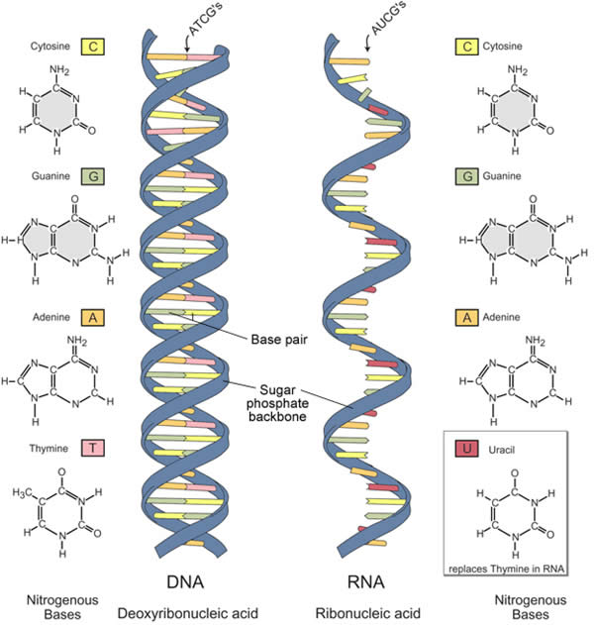

RNA Structure
Ribonucleic acid (RNA) is a similar molecule to DNA.
However, it has some key differences.
 | Deoxyribonucleic acid (DNA) | Ribonucleic acid (RNA)
Number of strands | 2 | 1
Sugar | Deoxyribose | Ribose
Base pairs | A-T G-C | A-U G-C

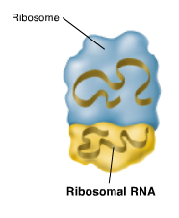
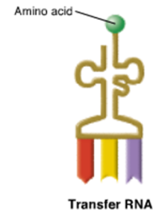
In addition to those differences, there are three different types of RNA. These different types have various shapes and functions.
Messenger RNA (mRNA) carries the transcripted message from DNA to the ribosome to make proteins
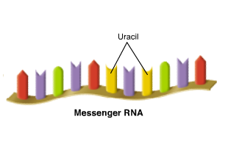
Transfer RNA (tRNA) brings the amino acids to the ribosome for protein synthesis
Ribosomal rna (rRNA) is a component of the ribosome and the site of protein synthesis

Transcription
This occurs in the nucleus of eukaryotes. In the process of transcription, an mRNA transcript is made using the double helix as a template. The double-stranded molecule of DNA separates along the hydrogen bonds. An enzyme called RNA polymerase adds in corresponding base pairs. However, instead of using Thymine to match up with Adenine, Uracil is used. For RNA, the base paring rules are A-U and G-C. At the end of this process, one piece of mRNA is created. It is complementary to the strand of DNA is was formed from.
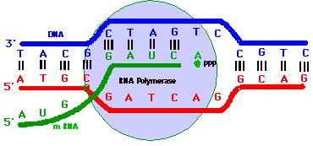

Translation
This process occurs in the cytoplasm. In the process of translation, the piece of mRNA is read by the ribosome in groups of three letters (codons). Each 3-letter portion of mRNA is referred to as a codon and codes for a specific amino acid. These codes match up to the anticodons on the bottom of the tRNA molecules. The corresponding tRNA molecule brings in the correct amino acid (building block of proteins). The ribosome joins the amino acids together to make a protein.
The diagram on the left shows replication, transcription, and translation all happening in the cell. The diagram on the right shows a chart of the 64 codons that make up the genetic code and the 20 amino acids that match up.
Each 3-letter portion of mRNA is referred to as a codon and codes for a specific amino acid. These codes match up to the anticodons on the bottom of the tRNA molecules.
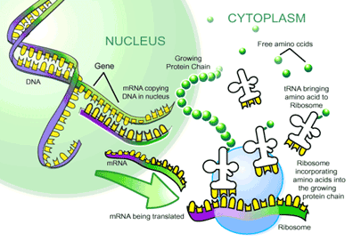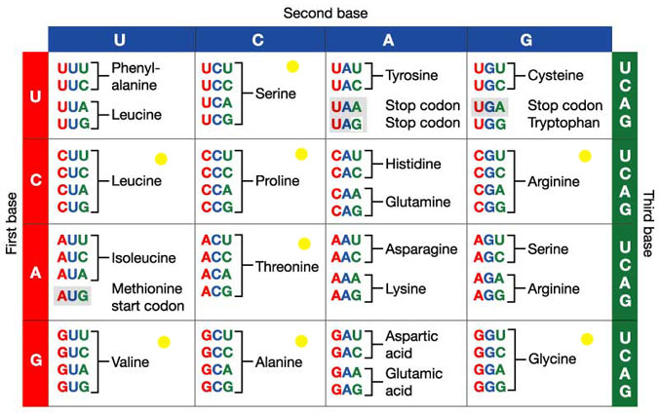
Mutations
Many different types of mutations can occur. They can either affect a few nucleotides (point mutations) or affect large portions of DNA (chromosomal mutations). These will ultimately affect the shape and size of the protein constructed, and the appearance of the cell or organism.
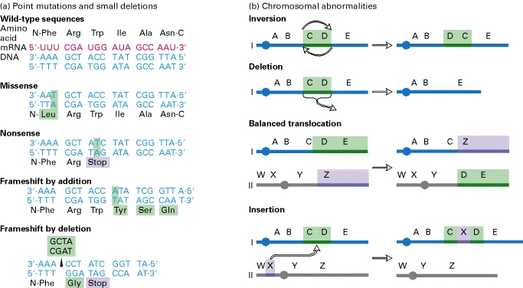

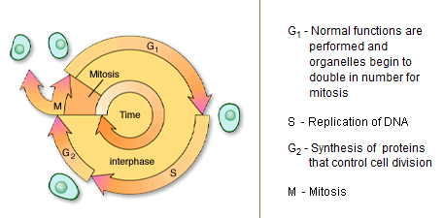Cell Cycle

3 main phases:
- Interphase – longest phase; divided into:
  - G1 – new cell grows
  - S – cell replicates DNA (synthesis)
  - G2 – cell produces proteins needed for mitosis
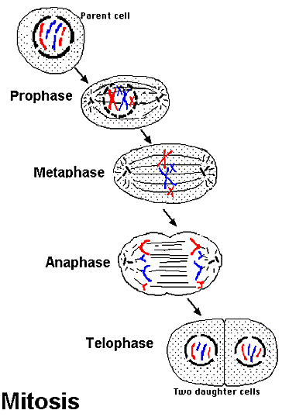
- Nuclear Division – mitosis
- Cytokinesis – original parent cells splits into two daughter cells

Stages of Mitosis
Mitosis is the process by which the contents of the eukaryotic nucleus are separated into 2 genetically identical packages.

Phases:
- Prophase - the nuclear envelope disintegrates and a spindle of microtubules forms
- Metaphase – spindles attach to the centromeres on the sister chromatids and they line up along the center of the cell
- Anaphase - centromeres separate and the sister chromatids, now termed chromosomes, are pulled toward opposite poles of the spindle
- Telophase - a nuclear envelope forms around each set of chromosomes, the spindle disappears and the chromosomes condense again

Meiosis
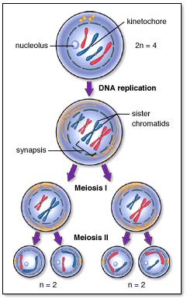
The ultimate goal of meiosis is to reduce the number of chromosomes by half. This must occur prior to sexual reproduction. The cell at the top contains two homologous pairs of chromosomes, for a total of four chromosomes. The final products of meiosis, four daughter cells, each contain one chromatid from each original homologous pair, for a total of two chromosomes. There are two stages of meiosis to accomplish this task

Meiosis I reduces the chromosome number in half, but each chromosomes contains two sister chromatids. Meiosis II further reduces the two sister chromatids into chromosomes resulting in to four haploid daughter cells.

Stages of Meiosis
Meiosis I
- Prophase I - identical sister chromatids are joined at the centromere; homologous chromosomes pair with one another and intertwine and may exchange segments. This exchange is called crossing over; the nuclear envelope disappears and the spindle forms
- Metaphase I - homologous pairs lie side by side as they reach the midplane of the spindle and attach to spindle fibers
- Anaphase I - partners in each pair of homologous chromosomes separate as they are pulled toward opposite poles of the spindle. These chromosomes still consist of sister chromatids joined at their centromeres.
- Telophase I - spindle disappears, nuclear membranes may re-form and the 2 nuclei, each containing a haploid set of chromosomes
Cytokinesis
Meiosis II
- Prophase II - the formation of a spindle; nuclear envelope disappears
- Metaphase II – duplicated chromosomes line up in the center and attached to spindle fibers
- Anaphase II - centromeres separate and sister chromatids, now considered chromosomes, begin moving in opposite directions
- Telophase II - nuclear membrane re-forms, the spindle disappears
Cytokinesis
