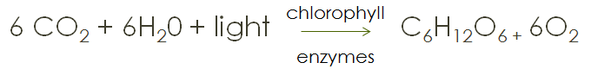
Topic 3: Bioenergetics

Photosynthesis
Plants:
- Autotrophs – they make their own sugars during photosynthesis = Producers - Produce food for all other organisms

Animals:
- Heterotrophs – must get their sugars (carbohydrates) for energy from other sources = Consumers – Consume the food provided by plants

Sun
- Ultimate source of energy because it provides the energy for the plants which is then passed down to other organisms

Photosynthesis
- The process by which plants convert the sun’s energy, water and carbon dioxide to sugar (glucose) and oxygen
- Takes place in the chloroplasts
- Chlorophyll is the molecule that receives the sun’s energy
- Chloroplasts are in the mesophyll cells of the leaves and stems (green parts) just below the surface of the leaf (or stem)

There are two major reactions in photosynthesis
- Light Dependent reactions
  - Aka Light Reactions
  - Light energy is absorbed by chlorophyll, which uses the energy to split water. Oxygen is released to the outside of the cell, the “H” part of H₂O is carried to the dark reactions with NADPH
  - Some ATP (energy) is made here—will be used up in Light Independent reactions
- Light Independent reactions
  - Aka Dark Reactions
  - Calvin Cycle
  - CO₂ from the outside is combined with the “H” part of NADPH to make sugars for the cell
    - NADP+ goes back to light dependent reactions
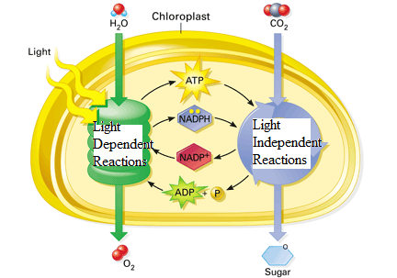
  - ATP is used to combine the CO₂ and H
    - ADP goes back to light dependent reactions

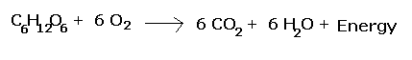
Respiration
Cellular respiration occurs in the mitochondria of eukaryotic organisms. It is composed of three major steps
- Glycolysis -- glucose is split into 2 3-carbon compounds and a small amount of energy is released.
  - Cytoplasm of all cells
- Kreb’s cycle – takes 3-carbon compounds and breaks them down into carbon dioxide
  - Inner part of mitochondria (matrix)
- Electron transport chain – takes electron carriers and materials to create a concentration gradient that ultimately creates ATP
  - Inner folds of mitochondria (cristae)
- Glycolysis - Metabolic pathway found in the cytoplasm that participates in aerobic cellular respiration and fermentation; it converts glucose to two molecules of pyruvate.
- Glucose - Six-carbon sugar that organisms degrade as a source of energy during cellular respiration.
- Energy - Capacity to do work and bring about change; occurs in a variety of forms.
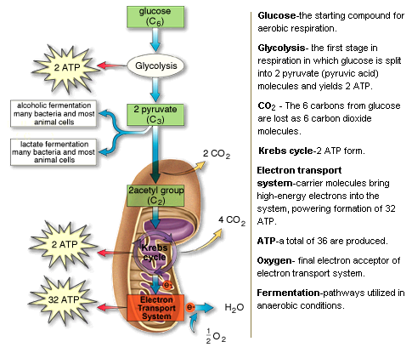
In the ABSENCE OF OXYGEN, some organisms will use the products of glycolysis and go through fermentation.
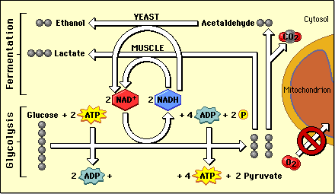
- Alcoholic fermentation—makes alcohol and CO₂ as the byproducts. Creates no ATP, but “refreshes” carriers so glycolysis can continue

- Lactic acid fermentation—makes lactic acid as the byproduct. Creates no ATP, but “refreshes” carriers so glycolysis can continue

